A Mini Project Report on

## Predicting Student Performance using Regression Analysis

Submitted in partial fulfillment of the requirements for the award of the degree of

### Bachelor of Engineering

in

### Computer Engineering

by

### Janhavi Anap (19102043)

### Prathamesh Hambar (19102001)

### Tejas Sheth (19102026)

### Het Patel (19102005)

Under the Guidance of

### Dr. Pravin Adivarekar



#### Department of Computer Engineering

A.P. Shah Institute of Technology G.B.Road,Kasarvadavli, Thane(W), Mumbai-400615

UNIVERSITY OF MUMBAI

#### Academic Year 2021-2022

This Mini Project Report entitled ***“Predicting Student Performance using Regression Analysis”*** Submitted by ***“Janhavi Anap” (19102043), “*** ***Prathamesh Hambar” (19102001), “*** ***Tejas Sheth”(19102026) ,“*** ***Het Patel” (19102005)*** is approved for the partial fulfillment of the requirement for the award of the degree of ***Bachelor of Engineering*** in ***Computer Engineering*** from ***University of Mumbai*** .

(Dr. Pravin Adivarekar)

Guide

Prof. Sachin H Malave

Head Department of Computer Engineering

Place:A.P.Shah Institute of Technology, Thane Date: 9th August 2021

This is to certify that the mini project entitled ***“Predicting Student Performance using Regression Analysis”*** submitted by ***“Janhavi Anap” (19102043), “*** ***Prathamesh Hambar” (19102001), “*** ***Tejas Sheth”(19102026), “*** ***Het Patel” (19102005)*** for the partial fulfillment of the requirement for award of a degree ***Bachelor of Engineering*** in ***Computer Engineering***, to the University of Mumbai, is a bonafide work carried out during academic year 2021-2022.

(Dr. Pravin Adivarekar)

Guide

Prof. Sachin H Malave Dr. Uttam D.Kolekar Head Department of Computer Engineering Principal

External Examiner(s) 1.

2.

Place:A.P.Shah Institute of Technology, Thane Date: 9th August 2021

We declare that this written submission represents our ideas in our own words and where others’ ideas or words have been included, we have adequately cited and referenced the original sources. We also declare that We have adhered to all principles of academic honesty and integrity and have not misrepresented or fabricated or falsified any idea/data/fact/source in our submission. We understand that any violation of the above will be cause for disciplinary action by the Institute and can also evoke penal action from the sources which have thus not been properly cited or from whom proper permission has not been taken when needed.

———————————————

(Signature)

———————————————

(Janhavi Anap 19102043)

(Prathamesh Hambar 19102001)

(Tejas Sheth 19102026)

(Het Patel 19102005)

Date: 9th August 2021

#### Abstract

The project focuses on predicting the final grade by analyzing the performance of the student. The prediction will be based on educational factors like cumulative GPA, personal factors like number of hours spent by a student for studying and social factors such as economical and educational background of their family and many more factors that may affect the GPA of the student.

It is important to find patterns in the student performance to be able to provide the necessary, accurate and timely diagnosis to the student. It also serves as a basic criterion for institutions to monitor the quality of education provided.

The Conventional Statistical Analysis and Artificial Neural Network prediction approach is necessary for the prediction. Conventional statistical evaluations help in identifying the multiple factors that actually affect the student performance. With these factors as input variables an Artificial Neural Network is modelled. Artificial Neural Network helps in analyzing large datasets which are not easily simplified through the conventional statistical techniques. It also helps to detect non-linear relationships between dependent and independent factors.

With the confirmation of the outputs from conventional statistical analysis, the training and testing of the model will be done for accurate prediction of the student performance. Performance of this neural network model is evaluated through various techniques. In this project one of the major techniques used for analysis is regression.

**Keywords:** Statistics, Analysis, Academics, Regression, Neural Networks

# Contents

1. **Introduction 1**
   1. Problem Definition 1
   2. Objectives 2
   3. Scope 2
   4. Existing System/Project 3
2. **Technology Stack 4**
3. **Benefits and Applications 5**
   1. Benefits for society 5
   2. Benefits for environment 5
   3. Applications. 5
4. **Project Design 6**
   1. Proposed System 6
   2. Flow of Modules 7
   3. Data Flow Diagram 8
5. **Implementation 9**
6. **Annexure A**
   1. Gantt Chart 12

**Appendices 13**

Appendix-A 13

**List of Figures**

1.1 Intrusion Detection System . . . . . . . . . . . . . . . . . . . . . . . .. 1

# List of Tables

1.1 An Example of a Table . . . . . . . . . . . . . . . . . . . . . . . . . . . . 2

5.1 Wormhole Attack Comparison with AODV Protocol . . . . . . . . . . . . . 6

**List of Abbreviations**

IDS: Intrusion Detection System

WSN: Wireless Sensor Network

MANET: Mobile Ad-Hoc Network

AODV: Ad-Hoc On-demand Distance Vector Routing

DSR: Dynamic Source Routing Protocol

NS2: Network Simulator 2

ACK: Acknowledgement

AGT: Agent

RTR: Router

**Chapter 1 Introduction**

The issues of how to prepare students to compete in a global economy are primary in education today. Prediction of student academic performance has long been regarded as an important research topic in many academic disciplines because it benefits both teaching and learning. Prediction of student academic performance will help instructors develop a good understanding of how well or how poorly the students in their classes perform, so instructors can be proactive. Non-Academic skills such as critical thinking, decision-making, and extra-curricular activities are as well essential for success in any walk of life. Predicted results are also important for the successful development of young people in society. Students who do well in academics will be better able to make the transition into adulthood and have a higher possibility of having employment opportunities and economic success.

Machine learning is a branch of artificial intelligence and computer science which focuses on the use of data and algorithms to imitate the way that humans learn, gradually improving its accuracy. Machine learning is an important component of the growing field of data science. Through the use of statistical methods, algorithms are trained to make classifications or predictions, uncovering key insights on student performance. Machine Learning will help us to predict students' grades with reasonable and significant accuracy, based on a given dataset.

Regression analysis is a predictive modelling technique that analyses the relation between the target or dependent variable and independent variable in a dataset. The different types of regression analysis techniques get used when the target and independent variables show a linear or non-linear relationship between each other, and the target variable contains continuous values.

The factors will be used in different regression algorithms and the most accurate model will be chosen for predicting student performance in upcoming semesters. The predictor/independent variables (namely, the inputs X1, X2, X3, etc.) of the regression models include a student’s

X1: Cumulative GPA

The previous academic performance of the student heavily influences the cumulative GPA mathematically. Also, students with higher GPAs are more likely to study more to maintain a higher GPA.

X2: Attendance

It gives an insight into a student's dedication towards the course.

X3: Hours spent studying

The number of hours spent studying enhances one’s grasping ability and helps keep pace with the instructor.

X4: Economical background of the family

Parents with stable incomes are more likely able to afford and provide the resources required for their education.

X5: Educational background of the family

Educated parents provide motivation to the students to perform well since they know the importance of education.

The scope of the present study is limited in the investigation of the effects of cognitive factors on student academic performance.

Some of the limitations faced are that some students may only study with a test-based approach and not a concept-based approach. This analysis may not be able to consider factors such as mental and physical health. Also, the unpredictability of human nature and emotions is beyond the control of any other factors.

* 1. **Problem Definition**

To design an artificial neural network model that predicts the marks obtained by a student in their final semester via regression. The model considers factors such as previous academic record, attendance, socioeconomic background, etc.

* 1. **Objectives**

The main purpose of the project is to analyze and improve upon the student results. The program will help professors to keep track of their weak students, who require extra attention. This project is a means which will eventually help the student, the professor to learn, analyze and grow from their past mistakes. Improve the success rate of schools/colleges, while monitoringstudents personally and have a clear picture of their goals and targets.

* 1. **Scope**

The project will include prediction of grades based on various factors. This will be implemented by training the data set on various machine learning models and selecting the best model that gives the maximum accuracy.

* 1. **Existing System/Projects**

You can also create section and subsection

A chapter can be divided into Sections, Sub-sections and Sub-sub Sections so as to present different concepts separately.

* + 1. **Subsection**

Sections and sub-sections can be numbered using decimal points, e.g. 2.2 for the second section in Chapter 2 and 2.3.4 for the fourth Sub-section in third Section of Chapter 2.

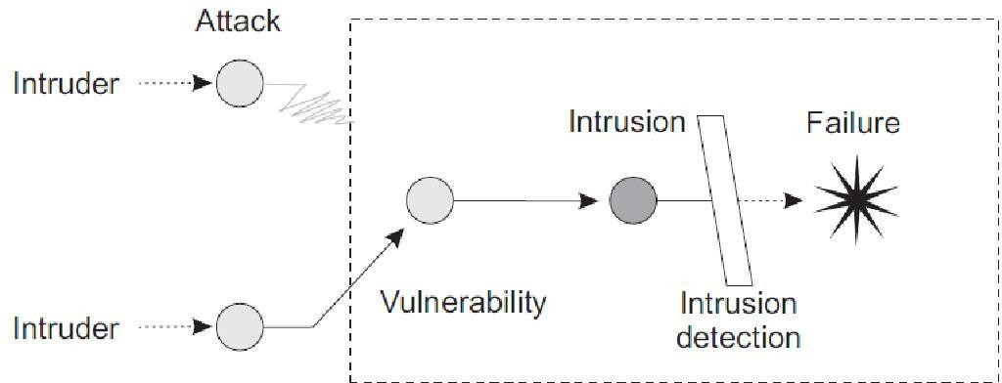

Figure 1.1: Intrusion Detection System

1. **Host-based IDS and**
2. **Network-based IDS.**
3. **Specification based Intrusion Detection.**
   * 1. **Use of Bullets**

ˆ item 1 ˆitem2 ˆitem3 ˆitem4

* + 1. **Use of Tables**

|  |  |
| --- | --- |
| One | Two |
| Three | Four |

Table 1.1: An Example of a Table

**Chapter 2 Technology Stack**

* + **Python**: It is a General Programming Language used to code the model. It involves usage of several libraries such as numpy, pandas, scikit-learn, etc.
  + **VS Code/Anaconda**: Integrated Development Environment to run, train and test the ML model
  + **Git and Github**: A Version Control System used for collaboration
  + **Google Analytics/Tableau/Power BI**: Data Visualization Tool to visualize the dataset and gain some insights
  + **Teamgantt** : Project Management Tool to improve team coordination and file sharing using gantt chart

**Chapter 3**

**Benefits and Applications**

* 1. **Benefits for society**
  2. **Benefits for environment**
  3. **Applications**

**Chapter 4 Project Design**

* 1. **Proposed System**
  2. **Flow of Modules**
  3. **Data Flow Diagram**

**Chapter 5**

**Implementation**

**Input:**

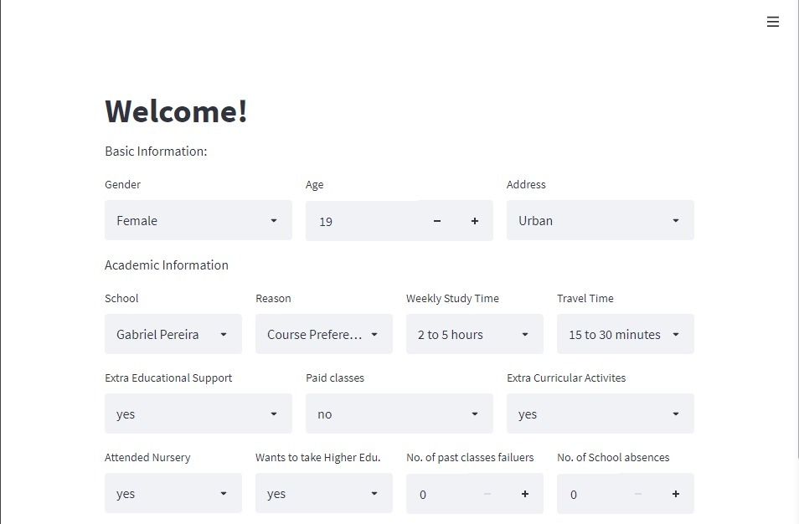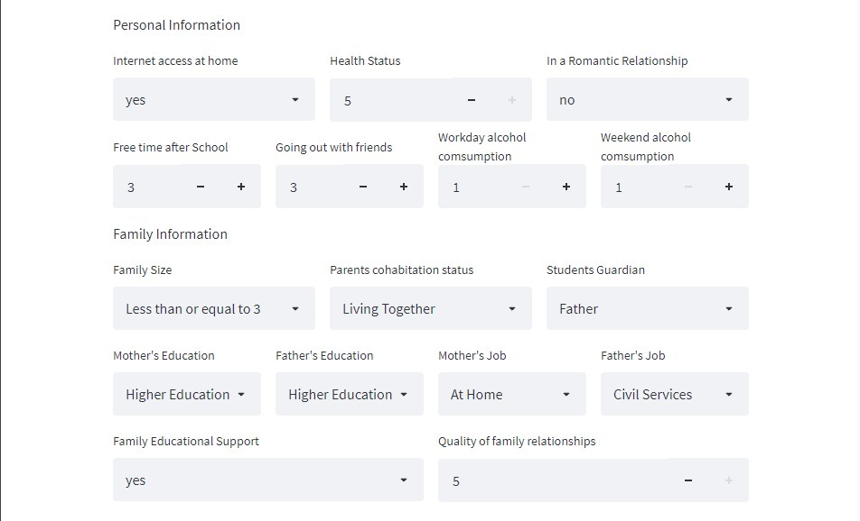 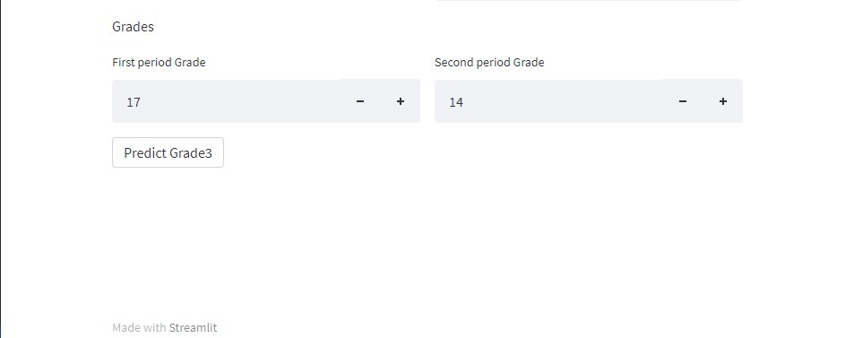

Fig 5.1 Input Snippet

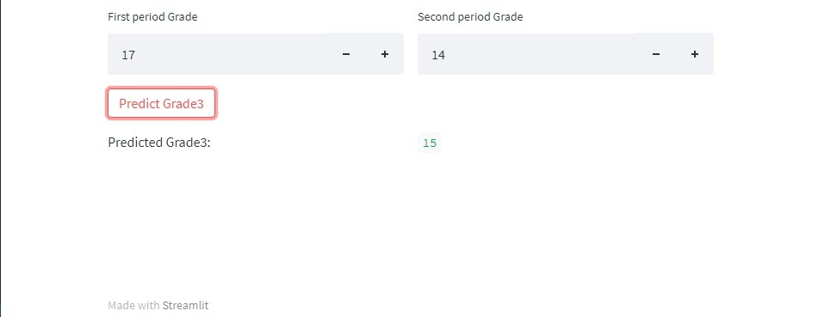

Fig 5.2 Output Snippet

**Chapter 6 Annexure A**

**6.1 Gantt Chart**

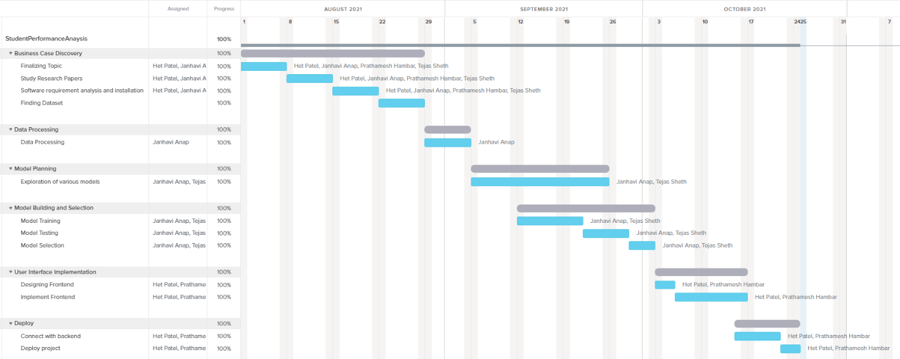

Fig 6.1 Gantt Chart

**Bibliography**

1. Abror Abduvaliyev, Al-Sakib Khan Pathan, Jianying Zhou, Rodrigo Roman and Wai- Choong Wong ,“On the vital Areas of Intrusion Detection Systems in Wireless Sensor networks”,IEEE Communications Surveys & Tutorials, Accepted For Publications, 2013- in press.
2. H.H. Soliman, et al,“A comparative performance evaluation of intrusion detection tech- niques for hierarchical wireless sensor networks”, Egyptian Informatics Journal (2012) 13, 225238.
3. Giannetsos Athanasios, “Intrusion Detection in Wireless Sensor Networks”, Master THE- SIS, Carnegie Mellon University, April 8, 2008.
4. K.Fall and K.Varadhan,“The NS Manual”, <http://www.isi.edu/nsnam/ns/doc/ns>doc.pdf., 1 Feb 2014.
5. Jae Chung and Mark Claypool,“NS by Example-Tutorial”[,](http://nile.wpi.edu/NS/overview.html) <http://nile.wpi.edu/NS/overview.html>, 1 Feb 2014.
6. Network Simulator blog, [http://Mohittahilani.blogspot.com](http://mohittahilani.blogspot.com/) , 1 Feb 2014.
7. AWK Script for NS2, <http://mohit.ueuo.com/AWK-Scripts.html>, 1 Feb 2014.

**Appendices**

Detailed information, lengthy derivations, raw experimental observations etc. are to be presented in the separate appendices, which shall be numbered in Roman Capitals (e.g. Appendix I). Since reference can be drawn to published/unpublished literature in the ap- pendices these should precede the Literature Cited section.

**Appendix-A: NS2 Download and Installation**

1. Download ns-allinone-2.35.tar.gz from <http://sourceforge.net/projects/nsnam/>
2. Place ns-allinone-2.35.tar in your desired directory; like /home/vishal.
3. Go to terminal and do as following commands

**sudo apt-get update**

**sudo apt-get install automake autoconf libxmu-dev build-essential**

1. Extract ns-allinone-2.35 and after extracting go to folder ns-allinone-2.35 from Termi- nal as

$**cd ns-allinone-2.35**

$**./install**

1. Path Setting

$ **gedit .bashrc**

This command will open an existing file in editor. Just put the following path which is given bellow. [Remember that our ns-allinone path is /home/vishal. we will change this path according to our ns-allinone folder’s path]

export PATH=$PATH:/home/vishal/ns-allinone-2.35/bin:/home/vishal/ns-allinone-2.35/tcl8.5.10/ unix/home/vishal/ns-allinone-2.35/tk8.5.10/unix

export LD LIBRARY PATH=$LD LIBRARY PATH:/home/vishal/ns-allinone-2.35/otcl-1.14:/home/ vishal/ns-allinone-2.35/lib

export TCL LIRARY PATH=$TCL LIBRARY PATH:/home/vishal/ns-allinone-2.35/tcl8.5.10/library

After this save and exit.

1. Now type in terminal to check that, is all command we entered in .bashrc is correct or not? And To take the effect immediately

$**source .bashrc**

1. Then perform the validation test using this command.

$ **./validate**

1. Run ns2 using this command

$**ns**

We will get % prompt in our terminal. Now ns2 has been installed.

**Introduction**

The issues of how to prepare students to compete in a global economy are primary in education today. Prediction of student academic performance has long been regarded as an important research topic in many academic disciplines because it benefits both teaching and learning. Prediction of student academic performance will help instructors develop a good understanding of how well or how poorly the students in their classes perform, so instructors can be proactive. Non-Academic skills such as critical thinking, decision-making, and extra-curricular activities are as well essential for success in any walk of life. Predicted results are also important for the successful development of young people in society. Students who do well in academics will be better able to make the transition into adulthood and have a higher possibility of having employment opportunities and economic success.

Machine learning is a branch of artificial intelligence and computer science which focuses on the use of data and algorithms to imitate the way that humans learn, gradually improving its accuracy. Machine learning is an important component of the growing field of data science. Through the use of statistical methods, algorithms are trained to make classifications or predictions, uncovering key insights on student performance. Machine Learning will help us to predict students' grades with reasonable and significant accuracy, based on a given dataset.

Regression analysis is a predictive modelling technique that analyses the relation between the target or dependent variable and independent variable in a dataset. The different types of regression analysis techniques get used when the target and independent variables show a linear or non-linear relationship between each other, and the target variable contains continuous values.

The factors will be used in different regression algorithms and the most accurate model will be chosen for predicting student performance in upcoming semesters. The predictor/independent variables (namely, the inputs X1, X2, X3, etc.) of the regression models include a student’s

X1: Cumulative GPA

The previous academic performance of the student heavily influences the cumulative GPA mathematically. Also, students with higher GPAs are more likely to study more to maintain a higher GPA.

X2: Attendance

It gives an insight into a student's dedication towards the course.

X3: Hours spent studying

The number of hours spent studying enhances one’s grasping ability and helps keep pace with the instructor.

X4: Economical background of the family

Parents with stable incomes are more likely able to afford and provide the resources required for their education.

X5: Educational background of the family

Educated parents provide motivation to the students to perform well since they know the importance of education.

The scope of the present study is limited in the investigation of the effects of cognitive factors on student academic performance.

Some of the limitations faced are that some students may only study with a test-based approach and not a concept-based approach. This analysis may not be able to consider factors such as mental and physical health. Also, the unpredictability of human nature and emotions is beyond the control of any other factors.

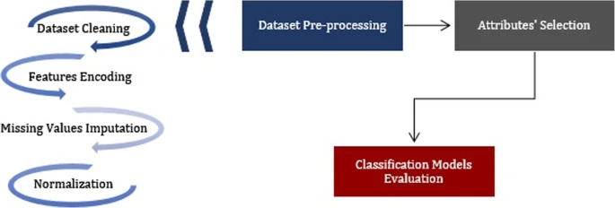

**Problem Statement**

To design an artificial neural network model that predicts the marks obtained by a student in their final semester via regression. The model considers factors such as previous academic record, attendance, socioeconomic background, etc.

**Requirements**

* **Python:** It is a General Programming Language used to code the model. It involves usage of several libraries such as numpy, pandas, scikit-learn, etc.
* **VS Code/Anaconda:** Integrated Development Environment to run, train and test the ML model
* **Git and Github:** A Version Control System used for collaboration
* **Google Analytics/Tableau/Power BI:** Data Visualization Tool to visualize the dataset and gain some insights
* **Google Workspace:** Project Management Tool to improve team coordination and file sharing

**Bibliography**

1. Huang, Shaobo, and Ning Fang. “Regression Models For Predicting Student Academic Performance In An Engineering Dynamics Course.” *ASEE PEER Document Repository*, 2010, <https://peer.asee.org/15759>.
2. Sujatha, G. & S, Sindhu & Savaridassan, P.. (2018). Predicting students' performance using personalized analytics. International Journal of Pure and Applied Mathematics. 119. 229-237.
3. Hussain, S., Gaftandzhieva, S., Maniruzzaman, M. et al. Regression analysis of student academic performance using deep learning. Educ Inf Technol 26, 783–798 (2021). <https://doi.org/10.1007/s10639-020-10241-0>
4. Lau, E.T., Sun, L. & Yang, Q. Modelling, prediction and classification of student academic performance using artificial neural networks. SN Appl. Sci. 1, 982 (2019). <https://doi.org/10.1007/s42452-019-0884-7>
5. Abu Zohair, L.M. Prediction of Student’s performance by modelling small dataset size. Int J Educ Technol High Educ 16, 27 (2019). <https://doi.org/10.1186/s41239-019-0160-3>

**Acknowledgement**

We have great pleasure in presenting the mini project report on **Predicting Student Performance using Regression Analysis.** We take this opportunity to express our sincere thanks towards our guide **Dr. Pravin Adivarekar** Department of Computer Engineering, APSIT thane for providing the technical guidelines and suggestions regarding line of work. We would like to express our gratitude towards his constant encouragement, support and guidance through the development of project.

We thank **Prof.Sachin Malave** Head of Department, Computer Engineering, APSIT for his encouragement during progress meeting and providing guidelines to write this report.

We also thank the entire staff of APSIT for their invaluable help rendered during the course of this work. We wish to express our deep gratitude towards all our colleagues of APSIT for their encouragement.

#### Student Name1: Janhavi Anap

**Student ID1: 19102043**

**Student Name2: Prathamesh Hambar**

**Student ID2: 19102001**

**Student Name3: Tejas Sheth**

**Student ID3: 19102026**

**Student Name4: Het Patel**

**Student ID4: 19102005**

12